

Item 10(1)

Report to the Executive for Decision
5 September 2011

Portfolio:  Subject:  Report of:  Strategy / Policy: | Streetscene  Review of Cemeteries Regulations and Burial Provision  Director of Community and Streetscene
Corporate Objective: | A Safe and Healthy Place to Live and Work

Purpose:
The purpose of this report is to advise members of:
  - proposed changes to the Council's cemetery regulations in order that some further clarity can be given on certain rules;
  - discussions that have taken place between the Council and the Parochial Church Council regarding the termination of a licence the Council has on a piece of land inside St Mary's churchyard; and
  - the current availability for future interments/burial space in Fareham cemeteries.

Executive summary:
Updating of cemetery regulations
Over the past few months, the Council has received some media coverage about the suitability of floral and other tributes placed within the Garden of Remembrance and memorial borders within Crofton and other Council Cemeteries.

With this in mind, consideration has been given to updating the current regulations in order that they provide clarity to relatives.

The proposed changes can been found in Section 10, 11 and 12 of the regulations, as set out in Appendix A.

St Mary's Churchyard
The Council licences an area of land within St Mary's Churchyard in Portchester under the Open Spaces Act 1906. The area of land is identified in Appendix B.
The church wishes to provide a Garden of Remembrance on the area of land contained within the licence. Officers have no objections to this proposal but consider that it would be a good opportunity to terminate this licence, which in turn, would allow the church the freedom and flexibility to progress with their project without third party considerations.

The proposals have been considered and are supported by the Streetscene Policy Development and Review Panel.

Current availability for future interments in Fareham's cemeteries
Within Fareham's cemeteries, there are a total of approximately 24,000 burial and cremated remains plots. Of these, 3,573 are vacant and 985 are pre-purchased (but as of yet unused). A more detailed breakdown can be found in Appendix C.

Recommendations:
Members are asked to:

- approve the revised and updated Cemetery Regulations;

- note the intention to terminate the licence that the Council has on land within St Mary's Churchyard; and

- note the current availability of grave space in Fareham cemeteries.

Reasons:
- the Cemetery Rules and Regulations are in need of updating in order that they provided better clarity for bereaved families and visitors to the Council's cemeteries, especially in relation to the personal tributes that are taken to the cemetery and laid in the Garden of Remembrance and in the memorial borders of the lawn burial areas.

- terminating the licence with the church to create a Garden of Remembrance on the area of land within the churchyard that was licensed to the council. The Council will no longer have to pay rent of £50 per annum and will no longer be responsible for the inspections of memorials in said area.

- the information will prove useful when making future decisions in relation to cemetery provision planning.

Cost of proposals:
There are no costs associated with the implementation of this report.

Appendices A: Cemetery regulations
B: Plan of St Mary's Church
C: Tables showing current cemetery provision

Background papers: Report to Health and Environment Review Panel - 10 January 2006 - Cemeteries Regulations, Burials and Churchyards

Report to Streetscene Policy and Development and Review Panel - 30 June 2011 - Revision and updating of the Cemetery Regulations and St Mary's Church Licence termination.

Executive Briefing Paper

Date: 5 September 2011

Subject: Review of Cemeteries Regulations and Burial Provision

Briefing by: Director of Community and Streetscene

Portfolio: Streetscene

INTRODUCTION
- The purpose of this report is to advise members of proposed changes to the regulations relating to the Council's cemeteries in order that some further clarity can be given on certain rules.

- The report also informs members of discussions that have taken place between the Council and the Parochial Church Council regarding the possible termination of a licence the Council has on a piece of land inside St Mary's churchyard.

revised cemetery regulations
- The regulations were last reviewed by the former Health and Environment Review Panel at its meeting on 10 January 2006.

- Since the last update of the regulations a few issues have arisen and it was considered that amendments were needed to aid relatives and provide clarity in certain areas.

- The primary alterations to the regulations reflect the need to clarify the tributes and floral displays that are permitted to be placed by relatives.

- Originally "Section Ten - Maintenance and upkeep of the cemetery" of the regulations included a mixture of rules that related to both what the Council was to provide in terms of maintenance as well as what was expected from relatives.

- In order to make it easier to understand section ten has been split into three sections as follows:

  - 10 -Tributes in the Garden of Remembrance;
  - 11- Planting and tributes in Lawn Grave Area; and
  - 12 - Maintenance and upkeep of the Cemetery.

- Section Ten now specifically provides guidelines for the Garden of Remembrance only. It outlines what tributes such as vases, ornaments, floral containers etc can be placed alongside memorial tablets.

- The Council has introduced a height restriction of 20cm for such tributes as it has been found that, over time, people tend to leave bigger and better tributes than the last relative and the height of some items has reached a height in excess of 120cm.

- The guidelines have been amended to specifically say that items such as wind chimes, garden ornaments on spikes etc are prohibited; however, it is proposed to allow solar lanterns as they are very popular.

- Section Eleven is very similar to Section Ten but specifically relates to the lawn grave areas. Memorial borders are provided for relatives to either plant shrubs or place floral tributes. However, in recent years, relatives have started to place multicoloured chippings around their memorials, with brick and other forms of edgings. In addition to these, items such as tall wind chimes, tall garden spikes and tall solar lights have appeared too.

- As with Section Ten, the guidelines are more specific as to what is permitted in the memorial border.

- Section Thirteen outlines what maintenance can be expected by the Council and what action will be taken if considered necessary.

- With regard to the pre-purchase of graves, further clarification has been made in Section Eight - Exclusive Right of Burial, in respect to Holly Hill Cemetery. There are no graves available in this Cemetery for pre purchase and current burials are only being undertaken where residents have previously purchased a grave in the past.

- It is hoped that the proposed alterations to the regulations will provide better clarification for relatives and reduce ambiguity.

st mary's chuchyard - termination of licence
- The Council licences an area of land which equates to approximately one third of St Mary's Churchyard in Portchester under the Open Spaces Act 1906. The Council was granted the licence, which expires on 31 August 2029, on 1 September 1971 by the Incumbent of St Mary's Parish Church. The area of land is identified in Appendix B.

- Under the terms of the licence, the Council is responsible to manage and maintain the site and pay an annual licence fee of £50 to the Parish. The Council is responsible for the grass cutting, memorial inspection and repair, tree pruning and the maintenance of the pathway leading to the entrance to the Church. The licence also enables the Council to apply for a faculty to lay out the area as an Open Space under the Open Spaces Act 1906.

- The Council has recently received a request from the Vicar of Portchester to construct a Garden of Remembrance in the area of the Churchyard currently licensed by the Council. This request has provided an opportunity for the Council to reflect on the need to license this area of land and to consider whether it would be in the interest of all concerned to agree to its termination.

- It is not known why the Council chose to agree to license this piece of land for the use as open space back in 1971. This area of churchyard is full of memorials and kerb sets and therefore could never realistically be utilised as open space.

- By revoking the licence, the control of the area would revert to the Incumbent and this would provide the Parochial Church Council with more flexibility with regard to its plans in creating the Garden of Remembrance.

- The Council would no longer be responsible for the management or maintenance of that area and would cease to pay the £50 annual licence fee to the parish. However, due to the fact that the Council has been cutting the grass in the rest of the churchyard since 1981, it has been suggested to the Church that the Council would continue to undertake all grass cuttings as it does currently.

- Officers and Church representatives are keen to progress the possible termination of the licence and members are asked to agree the proposal.

Current capacity for future interments in Fareham's cemeteries
- Within Fareham's cemeteries there are approximately 24,000 burial and cremated remains plots in total. (See Appendix C Table 1). Wickham Road Cemetery is the largest cemetery followed by Crofton and Roman Grove.
- Of those 24,000 plots, approximately 985 are pre-purchased (and unused) and 3573 are vacant. All other plots are in use with either one or two people buried in them.
- For every pre-purchased and vacant grave space there is the potential for two people to be buried so 'in theory' there is availability for approximately 9000 people. However, there are occasions when only one person is buried in a grave or long periods of time lapse between burials, which can distort projections.
- With regard to Fareham's annual burial figures, over the last ten years, on average, we have undertaken 129 burials and 99 cremated remains per year across the borough so, on that basis, one might conclude that there would be sufficient space to undertake burials for almost another 40 years.
- However, it is not quite as straight forward as it appears and predictions are difficult to make over such a long period of time due to unknown factors such as:
- future pre-purchased figures;
- time lapses between first and second burials in graves;
- the potential for each grave to only be used for one burial;
- increased life expectancy;

- cemetery provision in neighbouring authorities;
- trends in relation to burial vs. cremation (FBC only) (Appendix C Graph 1); and
- future increase in housing development/Fareham's population.

- It maybe prudent therefore, to suggest that there is sufficient grave space available for at least the next 25 years without running out of land for new burials.
- Should the Council ever be at risk of running out of burial space however, there may be an opportunity to 'reclaim' double depth graves that have not been purchased and have space available for a further burial. This potentially could generate space for a further 785 burials.
- Again, this figure needs to be viewed with caution as the information is based on data collected from old burial registers/records (although now kept electronically) and therefore reclaiming graves would have to be considered on an individual basis as an when an opportunity arose.
- Furthermore, there is potential for a new cemetery in the western wards at Coldeast to provide additional choice to those residents living in the west of the borough. At present, those living in that area have to be buried in cemeteries either in Titchfield or Stubbington. Funding needed for this new project will be in the region of £400,000.
RISK ASSESSMENT
- The Council's bereavement service and the maintenance of its cemeteries are considered to be one of the Council's most sensitive services and all communication with relatives and funeral directors has to be undertaken in a caring and sympathetic manner. Where possible, steps need to be taken to reduce any potential for misunderstanding and upset, so it is hoped that by clarifying certain aspects within the regulations this will help in this respect and there will be a reduced need to write to relatives asking them to remove tributes that are not considered to be in line with the rules.

- There are no significant risks associated with the termination of the licence with the Parochial Church Council; in fact it reduces the Council's ongoing liability of the inspections and repairs to a number of memorials present.

- With regard to future cemetery provision, obtaining accurate facts and figures about the available grave spaces in Fareham and making decisions based on that information reduces the risk and likelihood of actually running out of land and not being able to provide the required service in the long term future.

CONCLUSION

- This report has outlined minor changes proposed to be made to the regulations relating to the Council's cemeteries in order that some further clarity can be given on certain rules. The proposals are not of a significant nature, but it is hoped that relatives with loved ones interred in the Council's cemeteries will be able to fully appreciate the need for rules and regulations, which in turn allows the Council to provide the best facilities and surroundings as possible.

- The report has also advised members of the discussions that have taken place between the Council and Parochial Church Council in relation to the possible termination of a licence the Council has on an area of land inside St Mary's churchyard, Portchester.

- The report has outlined in detail the current status of Fareham's cemeteries in terms of future availability for interments. This information can be used to inform future decisions about the need for extra land for cemetery provision in the long term.

Background Papers:

Report to Health and Environment Review Panel - 10 January 2006 - Cemeteries Regulations, Burials and Churchyards

Reference Papers: None.

Enquiries:
For further information on this report please contact Sue Woodbridge (Ext 4546).

APPENDIX A

CEMETERY REGULATIONS

TABLE OF CONTENTS

1. INTRODUCTION

2. INTERPRETATION

3. MANAGEMENT OF THE CEMETERIES
Admission to Cemeteries
Conduct of visitors

4. INTERMENTS
Booking of interments
Hours for interments
Certificates of disposal
Infectious diseases

5. COFFINS/CASKETS

6. GRAVES
Allocations of new graves
Excavation of graves
Re-opening of graves
Exhumation

7. SCATTERING OF CREMATED REMAINS

8. EXCLUSIVE RIGHT OF BURIAL
What is an exclusive right of burial?
When can the exclusive right of burial be purchased?
Period for exclusive right of burial
Transferring the exclusive right of burial
Buy back by the Council of the exclusive right of burial

9. THE ERECTING OF MEMORIALS
Who can apply for the right to erect a memorial?
Applying to erect a memorial
Approval of memorial applications
Memorials – Lawn Graves - Permanent memorials
Temporary memorials
Memorials - Garden of remembrance
Memorials – General
Removal or re-erection of memorials
Responsibility of memorials
Inspection of memorials
The Council reserves the right

10. TRIBUTES IN THE GARDEN OF REMEMBRANCE

11. PLANTING AND TRIBUTES IN LAWN GRAVES AREAS

12. MAINTENANCE AND UPKEEP OF THE CEMETERY

13. FEES AND CHARGES

- INTRODUCTION

  - The following regulations shall apply to all the cemeteries under the control of Fareham Borough Council, situated at the following locations:

- Wickham Road, Fareham
- Crofton Cemetery, Oakcroft Lane, Stubbington
- Posbrook Lane, Titchfield also known as Claypits
- St Peter’s, Titchfield
- Roman Grove, Castle View Road, Portchester
- Holly Hill, Barnes lane, Sarisbury
- St Paul’s, Barnes Lane, Sarisbury
- St John’s, St John’s Road, Locks Heath

  - Wickham Road Cemetery has its own chapel, which can be hired to hold a memorial service.

  - The Council’s cemetery regulations form the basis for the proper control and management of the cemeteries and are designed to ensure a pleasant environment and ease of maintenance.

  - Visitors are welcome to the Cemeteries and are requested to respect the dignity of these peaceful and tranquil places. Regulations should be observed at all times and the Council reserves the right at any time to make amendments or variations to them

  - For enquiries regarding the regulations, please contact the Cemeteries Officer at the following office:

Fareham Borough Council
Civic Offices
Civic Way
Fareham
PO16 7PU

www.fareham.gov.uk
Telephone: 01329 236100

The Civic Offices are open between the following hours, except on Bank and Public Holidays:

Monday to Thursday 08.45 until 17.15
Friday 08.45 until 16.45

- INTERPRETATION

  - In these regulations, unless the context otherwise requires, the following words and expression are defined as below:
  - “The Council” refers to Fareham Borough Council being the Burial Authority for the Borough of Fareham.
  - “The Garden of Remembrance” shall mean the area of the cemetery where only cremated remains may be interred.
  - “A Lawn grave” shall mean a grave in the cemetery which is not part of the garden of remembrance where one exists. Memorials and floral tributes are only permitted in the memorial border and shall not encroach upon grass areas. In older areas of the cemeteries where there are no memorial borders, memorials may be placed at the head of the grave in alignment with other memorials.
  - “A grave” shall mean a Lawn grave or a plot in the Garden of Remembrance.
  - “Unpurchased grave” means a grave space wherein the exclusive right of burial has not been purchased. The Council has the right to undertake the interment of an unrelated person in an unpurchased grave after a period of 14 years. The only type of memorial permitted on an unpurchased grave is a vase.
  - “The owner of Exclusive Right of Burial” shall mean the person registered by the Council as the grantee of exclusive right of burial.
  - “Cemeteries Officer” is the Officer appointed by the Council to carry out the administration of the cemeteries.
- MANAGEMENT OF THE CEMETERIES
  - Admission to Cemeteries
    - Unless opening times are specified by the Council, entry to the cemeteries is restricted to the hours between sunrise and sunset.
    - No unauthorised person shall enter or remain in a cemetery at any hour when it is closed to the public.
    - The Council reserves the right to temporarily close to the public access to the cemeteries or any part of a cemetery at any time without notice.
    - All persons entering the cemeteries will be subject to these rules and regulations approved by the Council.
    - The Council reserves the right to exclude from the cemeteries for such period as the Council determines any person offending against these regulations.
    - Children are permitted in the cemeteries but should do so under the care and supervision of an adult.
    - Some but not all cemeteries have vehicle access. Admission of vehicles is subject to the following conditions:-

- Access is available during opening hours
- Access is subject to absolute right of way being given to any funeral cortege
- No vehicle is to be left in a position so as to cause an obstruction to other traffic
- A speed of 10 miles per hour is not exceeded
- Vehicles must only be driven on roads intended on vehicular use

    - To the extent permitted by law no liability is accepted by the Council for loss or damage to a vehicle or its content, or injury to its drivers or passengers however arising.
    - Dogs are permitted in the cemeteries but must be kept on a lead and under proper control at all times. Any dog faeces must cleared away immediately by the dog owner and disposed of in the bins provided.
  - Conduct of visitors
    - All persons shall conduct themselves in a decent, quiet and orderly manner and are reminded of the provisions of Articles 18(1) of The Local Authorities’ Cemeteries Order 1977. These state that no person shall:

- Wilfully create any disturbance in a cemetery;
- Commit any nuisance in a cemetery;
- Wilfully interfere with any burial taking place in a cemetery;
- Wilfully interfere with any grave, walled grave or vault, any tombstone or other memorial, or any flowers or plants or any such matter; or
- Play at any game or sport in a cemetery.

    - Every person contravening any of the above provisions is liable on summary conviction (currently £1000, and in case of a continuing offence to a fine not exceeding £10 for each day during which the offence continues conviction thereof.
    - Musical instruments may be played only with the prior consent of the Council.
    - Visitors are requested to deposit litter, spent flowers or any other unwanted items in the bins provided.
    - No persons shall sell or offer or expose for sale any article, commodity or thing of any kind whatsoever or solicit orders for the same, within the cemeteries.
    - All enquiries, complaints and requests by members of the public should be made to the Cemeteries Officer.
    - All visitors must refrain from interfering with trees, shrubs and flowers.
- INTERMENTS

  - Booking of interments

    - Prior telephone booking is required for every interment and a Notice of Interment, on the forms provided by the Council must be submitted to the Cemeteries Officer during normal office hours at least 2 clear working days before the date and time of the interment.

    - The notice of interment is also the confirmation of the telephone booking which is provisional until the Cemeteries Officer checks the Notice of Interment. The Council will not accept any responsibility for consequences arising from the loss or delay of any such notice, order or any other document sent by post nor for the accuracy of the details contained in the Notice of Interment.

    - The Notice of Interment must be signed by one of the following persons:

- The applicant for Exclusive Right of Burial
- The owner of Exclusive Right of Burial or the person authorising the opening or re-opening of the grave for his interment
- A person instructing an interment in an unpurchased or common grave

4.1.4 The person/s arranging the interment shall be responsible for the attendance of a Minister of Religion to officiate at the burial service (if desired) and for the payment of any fee to which the Minister is entitled.

  - Hours of interments

4.2.1 Interments may only take place in accordance with these regulations, subject to availability and between the hours of:-

Monday to Thursday 1000 to 1500 hrs
Friday 1000 to 1430 hrs

4.2.2 No burials may take place on Saturdays, Sundays or on Bank or other Public Holidays. In special circumstances and by prior arrangement interments may take place outside of these hours however additional charges will be incurred.

4.2.3 The time appointed for an interment will relate to when the funeral cortege is to arrive at the grave side (or the Chapel) where the interment is to take place. All funerals shall be under the control of the appropriate representative of the Council.

4.3 Certificates of disposal

4.3.1 No burial will be allowed to take place unless one of the following certificates is delivered to the appropriate representative of the Council before an interment takes place.

- A Coroner’s Order for burial or the disposal certificate issued by the Registrar of Births;
- In the case of a stillborn child, the appropriate certificate under the Births and Deaths Registration Act 1953;
- In the case of a non-viable foetus the Medical Practitioner’s or Midwifes’ certificate of delivery will be required;
- In the case of interment or a scattering of cremated remains, the cremation certificate issued by the Cremation Authority.

4.4 Infectious diseases

4.4.1 Where a funeral is of a person who has died of an infectious disease, the Notice of Interment must contain a statement to this effect. The body of a person who died from an infectious disease will not be allowed to be taken into the Cemetery Chapel.
- COFFINS/CASKETS

  - Every body brought into the cemetery for interment shall be contained in a suitable coffin /casket bearing a name plate establishing the identity of the body contained therein.

  - Traditional wooden coffins or ecologically friendly coffins only shall be used. No metal or plastic type coffins/cremated remains caskets will be allowed.

  - The exact dimensions of the coffin shall be entered on the Notice of interment. Should the coffin be in excess in size an additional charge may be incurred.

  - The responsibility for providing sufficient bearers to carry the coffin rests with the funeral director or person arranging the funeral.

- GRAVES

6.1 Allocation of new graves
    - Some cemeteries are segregated by religious denominations. Enquiries about sections of the cemeteries reserved for different religious groups should be made to the Cemetery Officer and the allocation of graves in these sections is subject to availability.

    - The allocation of grave spaces in all cases shall be at the discretion of the Council. If requested at the time of booking the interment, new graves will be available for selection subject to the approval of the Council and payment of the appropriate fee. Graves will not be available for selection in areas not currently active.

6.2 Excavation of graves

6.2.1 All graves shall be prepared by persons employed by the Council, or its contractors.

6.2.2 Every grave shall be dug central to the allocated grave space. All new graves shall be excavated at 1.93m subject to ground conditions allowing for two burials to take place in each grave space. Re-opened graves will be excavated at 1.50m; children’s graves shall be excavated at 1.20m and cremated remains plots at 0.60m.

6.2.3 Two cremated remains interments may take place in each plot in the Garden of Remembrance.

6.2.4 Cremated remains interments may take place in a Lawn grave; however the depth at which the cremated remains are placed depends on whether any previous interments have taken place. It is the Council’s policy to safeguard burial space.

    - The Council reserves the right to place excess spoil on graves, which may temporarily restrict access, when adjoining graves are excavated, and will endeavour to clear the spoil and leave the area tidy as soon as possible after the funeral.

    - No body shall be buried in a grave in such a manner that any part of the coffin is less than 0.91 metres below the level of any ground adjoining the grave; provided that the Council may, where they consider the soil to be of suitable character, permit a coffin to be placed not less than 0.61 metres below the level of any ground adjoining the grave.

    - No new brick graves or vaults will be allowed to be constructed

6.3 Re-opening of graves

6.3.1 Graves may be re-opened for further interments subject to space being available.

6.3.2 Where any grave is re-opened for the purpose of making another burial therein no person shall disturb any human remains interred therein or remove them from any soil which is offensive.

6.3.3 No body shall be buried in a grave unless the coffin is effectively separated from any coffin interred in the grave on a previous occasion by a layer of earth not less than 15 cm thick.

6.4 Exhumation

6.4.1 After interment no body or cremated remains may be removed from a grave without the production of the ecclesiastical faculty and/or Home Office Licence for exhumation required by law. The original documents will be required for this purpose.

7 SCATTERING OF CREMATED REMAINS

7.1 Permission may be sought from the Council to scatter cremated remains over a grave space. A Notice of Interment shall be submitted to the Council for this purpose.

8 EXCLUSIVE RIGHT OF BURIAL

8.1 What is an Exclusive Right of Burial?

8.1.1 The Exclusive Right of Burial entitles the registered owner:

- to be interred in a grave subject to space being available in the grave,
- to determine who is buried in the grave and
- to apply for the Right to erect a memorial on the grave, in accordance with regulations.

8.2 When can the Exclusive Right of Burial be purchased?

8.2.1 The Exclusive Right of Burial may be purchased in advance of an interment taking place to reserve a grave space subject to availability, with the exception of Holly Hill Cemetery, where there are no graves available.

8.2.2 The Exclusive Right of Burial in a grave may be purchased at the time of interment.

8.2.3 The Exclusive Right of Burial may be purchased after an interment has taken place in order to erect a memorial and/or prior to the re-opening of the grave for the interment of another person in the grave.

8.2.4 The option to purchase the Exclusive Right of Burial of an unpurchased grave is open to relatives at any time subsequent to the interment and must be exercised before an interment of an unrelated person has taken place in the same grave. If the grave remains unpurchased, the Council has the right to undertake the interment of an unrelated person in that grave, after a period of 14 years.

8.3 Period of exclusive right of burial

8.3.1 The Exclusive Right of Burial will be granted for a period of 30 years and will be renewable for successive periods of 30 years by the Owner of Exclusive Right of Burial.

8.3.2 An application should be made for renewal of the Right within 12 months of the expiry of the previous grant.

8.3.4 Where the period of grant of Exclusive Right of Burial has elapsed and no notification of an intention to renew has been received from the person who was granted the Exclusive Right of Burial or his/her successors, the Council may grant a renewed Right of Burial to any other person, but before doing so will where possible, attempt to notify the previous owner of the Right, or his/hers successor (if known) and give the option of renewal.

8.3.5 The owner of Exclusive Right of Burial is responsible for informing the Council of any change of address.

8.4 Transferring the Exclusive Right of Burial

8.4.1 The owner of Exclusive Right of Burial may assign the Right of Burial to another person subject to the appropriate administration fee.

8.4.2 After the death of the owner of Exclusive Right of Burial, the Council will need to re-establish the new legal owner of Exclusive Right of Burial. In order to transfer ownership it will be necessary to submit details requested in the transfer of grave ownership and the appropriate transfer fee. Such a transfer will be registered in the Council's records.

8.5 Buy back of Exclusive Right of Burial

8.5.1 Where no interment has taken place in the grave, the owner of the Right of Burial may surrender the same to the Council in return for a payment not exceeding the original purchase price. An administration fee is also payable to the Council, on such instances. No refund will be made where the Exclusive Right period has lapsed.

9 THE ERECTING OF MEMORIALS

9.1 A memorial may only be erected on a grave space within the Council’s cemeteries in accordance with the regulations in force at the time of application.

9.2 Who can apply for the Right to Erect a Memorial?

9.2.1 The Right to Erect a Memorial may be applied for only when the Exclusive Right of Burial for a grave space has been purchased. The right to erect a memorial rests with the registered owner of Exclusive Right of Burial.
9.2.2 The Right to Erect and maintain a memorial in the lawn graves area will be granted for a period of 10 ten years and will be renewable for successive periods of 10 years dependant on the memorial being safe. The right to erect and maintain a memorial in the garden of Remembrance will be for the duration of the Grant of Exclusive Right of Burial, i.e. Up to 30 years.

9.2.3 The period of Right to Erect a Memorial shall not exceed the period of exclusive right of burial.

9.3 Applying to erect a memorial

9.3.1 An application for the Right to Erect a new memorial, to place a new memorial, vase, alter or add to any inscription, refurbish or refix, or replace an existing, add to or remove from the cemeteries any memorial must be submitted to the Cemeteries Officer on the appropriate Memorial Application Form.

9.3.2 The application form must be submitted at least 14 days before undertaking any works.

9.4 Approval of memorial applications

9.4.1 An application for the right to erect a memorial will be confirmed by a deed of grant to the applicant and the issue of a Memorial permit. Memorial permits can only be issued to Memorial Masons registered by the Council or Members of the British Register of Accredited Memorial Masons and any memorial work undertaken must fully comply with the terms and conditions specified in the registration scheme and each memorial erected or re-erected guaranteed in respect of safety and stability including faulty workmanship during the specified period.

9.4.2 A memorial can only be erected on the condition that it may be periodically inspected by the Council and must be found to be safe. Any necessary repairs required must be carried out by a Memorial Mason as above. If this is not undertaken, then the Council reserves the right to remove the memorial and terminate the right.

9.5 Memorials - Lawn graves

9.5.1 The Council’s cemeteries are laid to lawn and the placing of memorial tablets or kerbs around the graves is not permitted. No new kerbstone shall be installed nor will any enclosure of any description be allowed. The erection of any form of railings is not permitted around any grave.

9.5.2 A memorial can be erected central to the memorial border in the newer areas of the cemeteries and in the absence of any memorial borders, in the older areas of the cemeteries, at the head of the grave in alignment with other memorials.

(A) Permanent Memorials

The maximum size of memorials shall not exceed 90 cm in height by 90 cm in width by 30 cm in depth or if the memorial is to be erected over two grave spaces 90 cm in height by 200cm in width by 30cm in depth

Memorials erected in the children’s section shall not exceed 60 cm in height by 60 cm in width by 30 cm in depth.

Flower vases less 30cm in height are only permitted in the memorial border or in the absence of a memorial border at the head of the grave. If a vase is placed next to a headstone, both memorials should be placed central to the grave space and their added width size should not exceed the maximum width size permitted.

Memorial tablets (as defined in paragraph 9.6.1 below) and kerbstones are not permitted.

(B) Temporary Memorials

A temporary wooden cross not exceeding 90 cm in height above ground level by 60cm wide may be erected at the head of the grave for the first twelve months following an interment. This temporary memorial shall be removed by the Owner of Exclusive Right of Burial or Memorial Mason when a permanent memorial is erected and before the 12 months has elapsed. The Council reserves the right to remove and dispose of the cross, should it fall in disrepair or if it remains on site at the expiration of the permitted period.

The erection of a wooden cross is subject to the approval by the Council of a memorial application.

9.6 Memorials - Garden of Remembrance

9.6.1 Flat memorial tablets not exceeding 5 cm in height by 45 cm in width by 35 cm in depth may be placed in a ‘landscape’ position over the site of a cremated remains plot. The tablet must be set flush to ground level and can incorporate a vase.

9.7 Memorials - General

9.7.1 All memorials shall be constructed out of natural stone, granite, marble or other hard stone, which must be durable and sound.

9.7.2 The number of the grave shall be engraved on the back of all new and replaced headstones in letters not less than 15mm in height.

9.7.3 Only memorial vases are permitted on unpurchased Lawn graves (graves that don’t have a registered owner).
9.7.4 It is the responsibility of the Memorial Mason to ensure memorials are erected on the grave space, at the appropriate levels to the adjacent ground and central to the memorial border or in the absence of a memorial border at the head of the grave in alignment with other memorials. All Memorial Masons shall carry out their work strictly under the direction of the Council and shall fill up and level the ground, remove all waste and unwanted material and make good any damage or injury whatsoever occasioned in the process of the work.

9.7.5 Work on memorials shall not be carried out on Saturdays, Sundays, Bank or other Public Holidays.

9.8 Removal or re-erection of memorials

9.8.1 The removal and re-erection of a memorial to facilitate the re-opening of a grave or to level such grave shall be at the expense of the grave owner or their personal representative. Such work shall be undertaken by a Memorial Mason registered by the Council or masons who are members of the British Register of Accredited Memorial Masons and such memorial shall be replaced as soon as practical after the interment. An application to re-erect the memorial with an additional inscription shall be submitted to the Council.

9.9 Responsibility for memorials

9.9.1 Any monument or memorial erected in the Cemetery remains the property and responsibility of the owner of Exclusive Right of Burial for the grave or their personal representative and therefore, remains in the Cemetery at the sole risk of, and must be kept in good state of repair, by the said owner or personal representative.

9.9.2 The Council will not accept liability for damage to any grave space or memorial or injury to any person within a cemetery except where such damage is directly attributable to the negligence of the Council or their employees.

9.9.3 The Council recommends that memorial owners take out insurance to protect their property.

9.10 Inspection of memorials

9.10.1 The Council periodically inspects all memorials and if any are found to be in an unsafe condition, the Council will place a notice on the memorial and will then contact the memorial owners in order that they can rectify any problems. Should the Council be unable to establish contact with an owner the Council will make the memorial safe or undertake such other remedial action to remove the danger as necessary.

9.10.2 Memorial owners shall be responsible for the cost of repairing or re-instating memorials. The Council will endeavour to notify memorial owners of unsafe memorials but if not repaired or contact not made within two months of this action, the memorial may be removed by the Council.

9.10.3 Where a necessary action has been taken in regard to any unsafe memorials and the costs of repair or removal has been borne by the Council, such costs will be recovered from the owner of the memorial or subsequent claimant to the Exclusive Right of Burial, should they become known to the Council.

9.11 The Council reserves the right

9.11.1 The Council reserves the right to:

9.11.2 Remove, without notice, any memorial and take any necessary precautions necessary to safeguard the Council’s employees or contractors when digging graves adjacent to any memorial.

9.11.3 To re-fix, move, line-up or otherwise alter the position of any memorial in a cemetery as they may require.

9.11.4 Remove any monument or memorial, which has become, or is likely to become, dangerous or which is in a derelict or unsightly condition.

9.11.5 Remove any monument or memorial where the periods of Exclusive Right of Burial and Right to erect of Memorial have elapsed or when the Right to Erect a Memorial is deemed to be terminated.

9.11.6 Remove any memorial or other item that is placed upon a grave in contravention of these regulations, without notice.

10 TRIBUTES IN THE GARDEN OF REMEMBRANCE

10.1.1 We respectfully request that all tributes placed in the Garden of Remembrance are not excessive, do not encroach on to adjoining plots, and do not restrict access to adjacent memorial tablets or obstruct the maintenance of the area.

10.1.2 The erection of any form of enclosure or low level fencing around the memorial tablet is not permitted nor is the planting of flowers and shrubs.

10.1.3 The Council does not have any objections if a small plant container such as a trough is placed immediately behind the tablet.

10.1.4 The placing of items such as lanterns, wind chimes and ornaments on hooks or spikes is not permitted in the Garden of Remembrance.

10.1.5 Vases, jars and bottles made from glass are not permitted in the Garden of Remembrance.

10.1.6 Other tributes of sentimental value including solar lanterns not exceeding 20cm in height can be placed in the Garden of Remembrance providing they are placed on the memorial tablet or adjacent to memorial tablets directly on or in the ground but not hung from a hook.

10.1.7 The Council reserves the right to remove without prior notice objects, materials, plant and flower containers which have become unsightly and plants, floral tributes and Christmas wreaths which in its opinion are considered to have died or are not in accordance with these regulations and to dispose of the same in such a manner as deemed fit.

10.1.8 The placing of new or the replenishing of existing chippings in the Garden of Remembrance can only be undertaken by the Council.

11 - PLANTING AND TRIBUTES IN LAWN GRAVE AREAS

11.1.1 We respectfully request that all lawn areas are kept clear of tributes in order that maintenance can be undertaken unhindered and that the width of the memorial border is not altered in any way.

11.1.2 The placing of floral tributes or the planting of small annual bedding plants, bulbs, and low growing shrubs is only permitted within the memorial border and shall be maintained by the grave owner.

11.1.3 Shrubs planted should not ultimately exceed 90cm in height and should be non-spreading in nature. The planting of conifers and other trees is not permitted as they can eventually grow very large and their roots can disturb the foundations of headstones and make them unstable.

11.1.4 The planting of flowers and shrubs is not permitted in the older areas of the cemeteries where there are no memorial borders.

11.1.5 The Council reserves the right to remove without prior notice any plant and flower containers which have become unsightly, shrubs, trees or plants, floral tributes and Christmas wreaths not considered to be accordance with these regulations, infringing on adjacent grave spaces or that in its opinion have become unsightly and to dispose of the same in such a manner as deemed fit.

11.1.6 Although care will be taken when excavating new graves, the Council does not accept any liability for loss or damage to planting caused as result of such operations.

11.1.7 The placing of items such as lanterns, wind chimes and ornaments on hooks or spikes is not permitted on any part of the grave or the memorial border.

11.1.8 Vases, jars and bottles made from glass are not permitted on any part of the grave or memorial border.

11.1.9 Other tributes of sentimental value including solar lanterns not exceeding 20cm in height can be placed in the memorial border directly on or in the ground but not hung from a hook.

11.1.10 The erection of any form of enclosure or low level fencing and the placement of chippings, pebbles and stones together with wooden, brick or concrete edging, on any part of the grave or the memorial border is not permitted.

11.1.11 The Council reserves the right to remove without prior notice any unauthorised memorials, materials, tributes not considered to be accordance with these regulations and may recover any cost incurred in doing so and reinstating any damage caused to the ground or any feature within the cemetery from the owner of the exclusive right of burial.

12- MAINTENANCE AND UPKEEP OF THE CEMETERY

12.1 Grounds maintenance operations such as grass cutting, leaf and litter clearing, upkeep of trees, shrubs, flower beds, hedges and memorial borders will be carried out by the Council or its contractor, at a frequency determined by the Council and by weather conditions.

12.2 The Council shall endeavour to reinstate all newly excavated graves within 12 months of an interment, subject to grounds conditions and to the season of the year being appropriate for these works to be undertaken. This period is necessary to allow the natural subsidence of the earth used to fill the grave. The reinstatement shall include the levelling and seeding of the grave surface.

12.3 No mound will be permitted over any new grave other than to allow for settlement.

12.4 Funeral wreaths will generally be disposed of within 14 days after interment; however, they may be left longer depending upon how well the flowers have lasted.

12.5 The Council may undertake the planting of roses in the memorial border.

12.6 The Council may place chippings in the areas surrounding the tablets in the Garden of Remembrance.

12.7 The Council reserves the right to disconnect the water supply during the winter months to avoid the freezing and ultimate bursting of the pipes, or when the tap(s) are defective or the water supply provided is being abused.

12.8 The Council reserves the right to change the appearance of the Cemetery and therefore the demeanours of the surround adjacent to a specific grave may change as may any amenity or feature adjacent to a grave.

13. FEES

13.1 Fees for cemetery services will be determined by the Council annually and will take effect from 1 April each year.

  - Fees are payable in advance to the Council except in the case of Funeral Directors and Monumental Masons, dealing continuously with the Council, who are invoiced monthly by the Council.

APPENDIX B
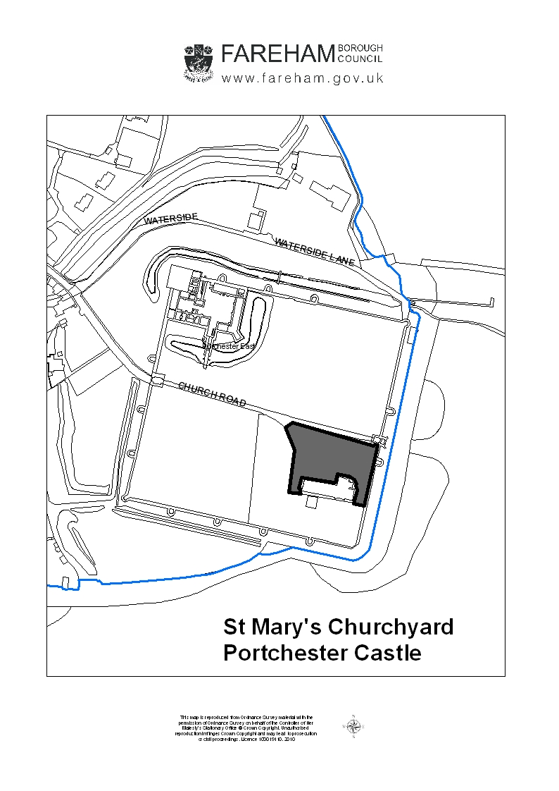
APPENDIX C
SUMMARY OF BURIAL & CREMATION PLOTS WITHIN FAREHAM CEMETERIES

Table 1. Current provision in Fareham's Cemeteries

CEMETERY | GRAVES |  |  | CREMATED REMAINS
CEMETERY | Occupied | Purchased | Vacant | Occupied | Purchased | Vacant | Total
Holly Hill Cemetery | 1037 | 129 | 6 | 210 | 47 | 70 | 1499
Crofton Cemetery | 1375 | 232 | 1091 | 569 | 77 | 264 | 3608
Crofton 2nd Ext | 649 | 13 | 6 |  |  |  | 668
Crofton old burial ground | 599 |  |  |  |  |  | 599
Crofton 1st ext | 397 | 2 | 4 |  |  |  | 403
Fareham Cemetery | 6807 | 202 | 531 | 196 | 26 | 115 | 7877
Roman Grove Cemetery | 2594 | 44 | 540 | 85 | 24 | 208 | 3495
St Johns Cemetery | 1202 | 30 | 5 |  |  |  | 1237
St Paul's Cemetery | 503 | 6 | 2 | 6 |  | 139 | 656
St Paul's Churchyard | 1661 | 15 | 20 |  |  |  | 1696
St Peters Cemetery |  |  |  | 291 | 29 |  | 320
Posbrook Cemetery | 1382 | 98 | 428 | 25 | 11 | 144 | 2088
 | 18206 | 771 | 2633 | 1382 | 214 | 940 | 24146

Graph 1. Graph showing trends for burials (B) and cremations (C) between 1864 and 2010 that are dealt with by Fareham Borough Council.

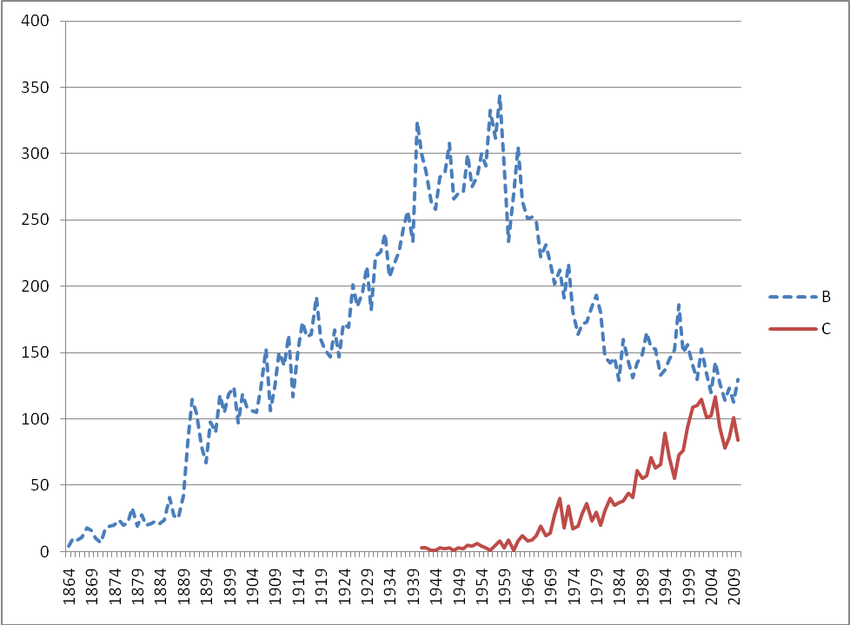

The information provided in this graph relate only to burials and cremations that have taken place in cemeteries that this Council are responsible for. These figures do not include for example all the cremations that take place at the crematorium but have been intered or scattered elsewhere or those people that have been buried in churchyard s that we don’t manage.

